Muon Lifetime (MUO)

Data Acquisition Electronics

The data you will be analyzing has been collected with the electronics described below.

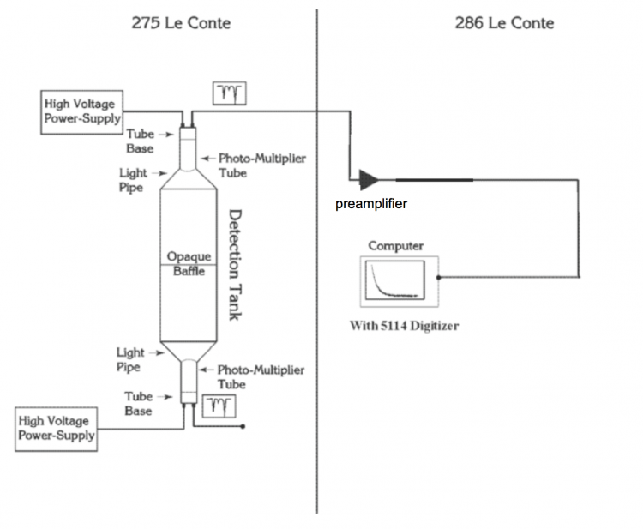

Figure 5: Block Diagram of the Muon Lifetime Experiment

(from the pre-covid lab manual http://experimentationlab.berkeley.edu/sites/default/files/writeups/MUO.pdf)

Only the top half of the "Detection Tank" in 275 LeConte shown above was utilized, so you will see in the data file that columns referring to the bottom photomultiplier tube signals are zeros. The high voltage supply settings are visible in the photograph below, which was taken during data collection. Nothing is seen connected to the HV output on the front because the HV is also present on the back and that is the output being used to power the PMT.

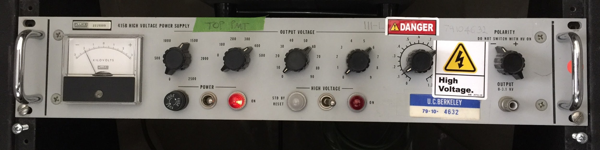

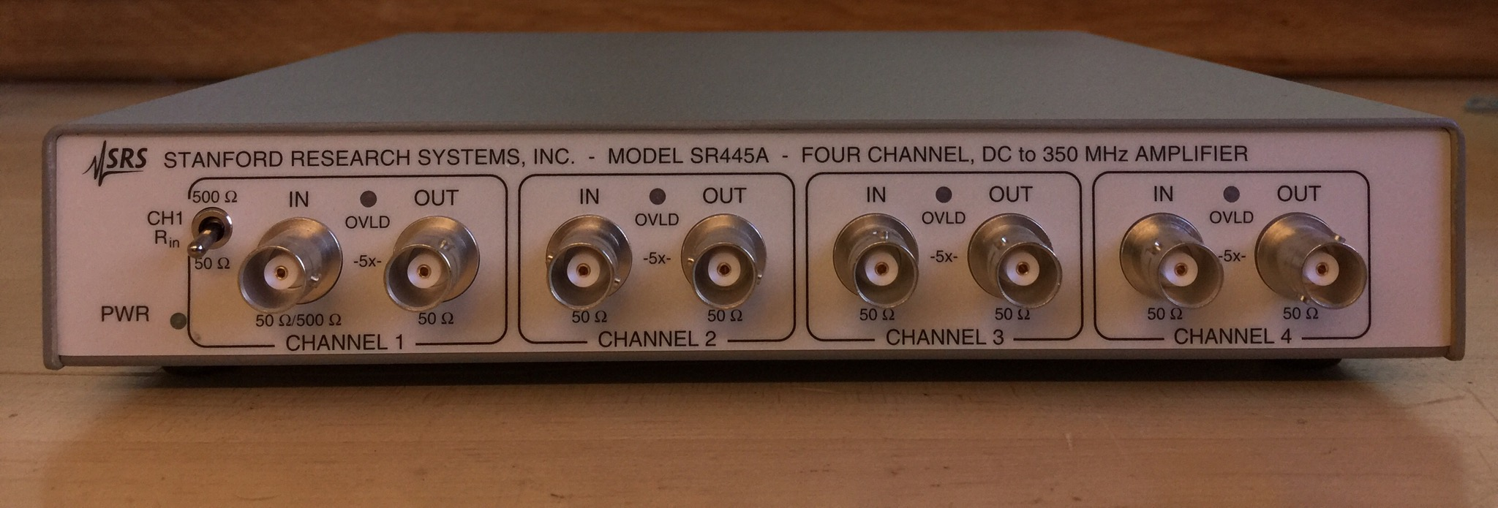

Above is a photo of an SRS SR445A amplifier, used as the "preamplifier" shown in Figure 5. Only one of the four SR445A amplification stages was used, with input and output impedances both 50 ohms. Everything is interconnected via 50-ohm coaxial cables. The photomultiplier tube (PMT) and connected tube base electronics have a 50 ohm output impedance. And the PCI-5114 input impedance is approximately 50 ohms.

The "5114 Digitizer" referred to in Figure 5 is an NI-PCI-5114 card plugged into the computer, enabling LabVIEW code to acquire pulse waveforms after amplification by the preamplifier. The PCI card is shown below.

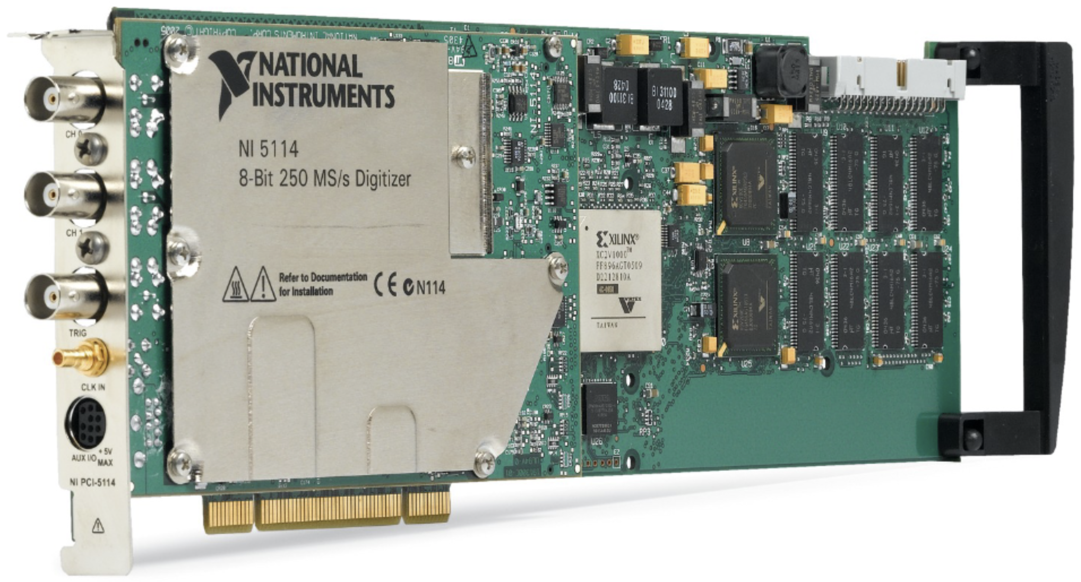

# PCI-5114 Oscilloscope Device

(Image from https://www.ni.com/en-us/support/model.pci-5114.html)

Software written in LabVIEW interfaces with the PCI-5114 card, directing it to collect data continuously into what's known as a circular buffer until a trigger condition is met. When that trigger occurs, the PCI card takes about 40 uS more data and stops so as not to overwrite the digitized waveform just collected, which spans from several uS before the trigger to 40uS after the trigger. Readout by the LabVIEW software takes considerably longer than the ~50uS during which the data was collected, after which the PCI-5114 is enabled again by the LabVIEW program to sample the input waveform and again await the trigger condition.

Once read into LabVIEW, the waveform data is analyzed to look for peaks. The peak detection criteria used for the data you are being given requires that two pulses be detected. How large a pulse must be in order to be counted is set by the threshold levels on the front panel of the LabVIEW program. Each time this occurred, a line of data was written into the data file. The LabVIEW front panel interface displays an "Output Count" which is the number of lines of data collected to be written to the file, and above that number is shown the "Trigger Count" which is the number of triggers, most of which did not meet the two-pulse criterion. The image below was captured shortly before completion of the 50-hour data collection run.

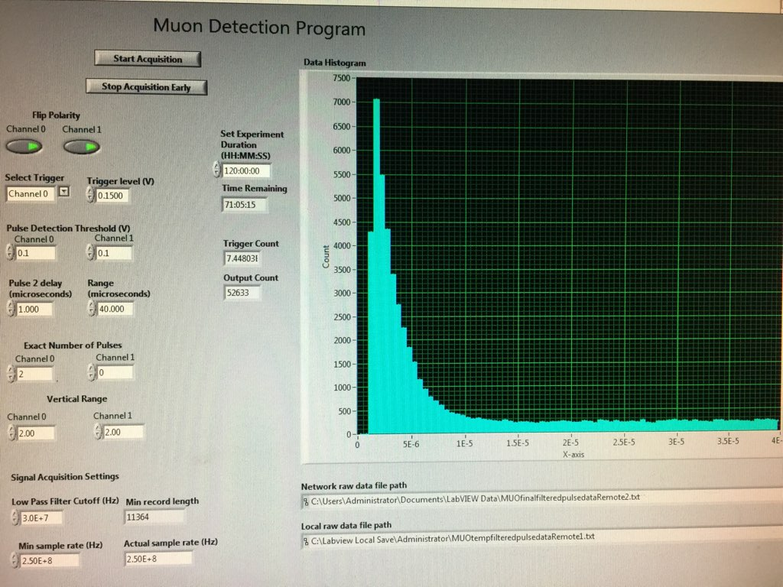

In the plot portion of the above image, the horizontal axis is seconds between the first and second of the two pulses. The vertical axis is the number of occurrences detected where that time difference was within a specific range. The left edge of each bar in that plot represents the center of that bin of times. Thus in this plot the bin containing about 1500 counts, just to the right of the 5E-6 (5 microseconds) mark, is the number of occurrences where the time difference between the two pulse arrivals was between 4.75 and 5.25 microseconds.

The above image shows the Trigger level set to 0.15 Volts, and the Pulse Detection Thresholds set to 0.1 Volts. A second 69-hour set of data is being collected with Trigger at 0.1 Volts and Thresholds at 0.06 Volts.

Calibration

**Linearity of pulse height measurement** (referenced to the PMT output signal) was measured by disconnecting the PMT signal and instead connecting the SRS DG645 Digital Delay Generator, two Wavetek 50 ohm decibel-scale attenuators and a Mini-Circuits ZSCJ-2-1+ Power Splitter in place of the PMT signal into the preamplifier as shown below.

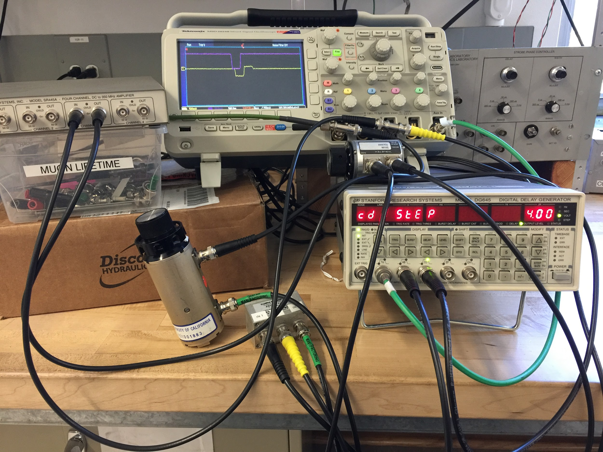

The AB and CD outputs were used to generate a 30nS wide positive 0.54 Volt pulse and a 30 nS wide negative 4.00 Volt pulse respectively, with the CD pulse delayed by 3uS with respect to the AB pulse. These pass through the attenuators set to 5 dB for the AB pulse and 20 to 44 dB attenuation for the CD pulse. The AB signal via the 5dB attenuator enters the Power Splitter at its inverting input IN1. The CD signal attenuated by various amounts from 20 to 44 dB enters the power splitter via its non-inverting port IN2. The DG645 signal generator is set to trigger this pair of pulses at 100 Hz, resulting in the following waveform.

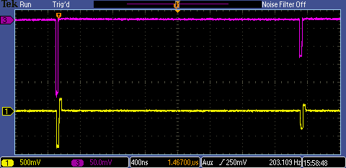

The first of the above pulses triggers the PCI-5114 to capture the waveform to be examined in software, and the second pulse meets the two-pulse criterion for the software to write the data, including the heights of the pulses, to the data file. For each attenuation (in 3dB steps) from 20 to 44 dB, about 500 to 600 such events have been captured. For reference, the case where the attenuation was set to 29 dB is where the second pulse was -100mV entering the 5x amplifier of the SR445A. In each case the triggering pulse was -200mV. As various attenuations were explored, at some point the signal is large enough that the red LED labeled OVLD on the SR445A lights up. This occurred at 21 dB attenuation (but LED was off at 22dB attenuation), so the data set collected up to 20 dB explores just a little into the amplifier's limiting region.

**Calibration of the digitizer's clock** may be determined from the 70Hz.* data set. This data was collected by delivering a constant-height pair of pulses to the data acquisition system and stepping the time difference between the two pulses up and down, covering whole microseconds in one direction and half microseconds (e.g. 2.5uS, 3.5uS) in the other direction. The pulse generator was run at 70Hz, generating 0.8 Volt pulses, positive AB pulse into the IN1 inverting input of the Power Splitter, and negative CD pulse into the non-inverting input IN2 of the Power Splitter. (To be precise, the "negative" pulses generated by the DG645 signal generator are not voltage inverted but rather logic inverted. However the Power Splitter removes the DC component making it a negative voltage pulse.)

**Time resolution of the digitizer** may be determined either by the above 70Hz data set or from the one of the data sets used to determine efficiency of the digitizer.

**Efficiency of the digitizer,** as a function of time difference between the two pulses, may be determined from either of two data sets.

The Cal100mV60mV30nS100mV290.* data set was collected with the muon signal combined with an added signal from the signal generator. This signal was added after the 5x amplification of the SR445A by means of a "Tee" connector and a 1.02 k Ohm resistor. To do this the 1.02 k Ohm resistor was connected from the signal generator output to the muon signal line via the "Tee" connector. After attenuation via this 1k resistor, the generator's signal appeared as a 30nS wide 100mV negative pulse on the muon signal entering the digitizer after the SR445A preamplifier. This amplitude was selected to be insufficient to trigger the software, however once triggered by a detection at the PMT this generated pulse acts as the second pulse, a pretend muon decay pulse, and is counted by the software as the second pulse needed to meet the two-pulse criterion for output data to the data file. The signal generator's rate was set to 12500 Hz so that up to half the time that a trigger (due to the PMT signal) occurs, the artificial second pulse will be seen within the approximately 50 microsecond digitized waveform.

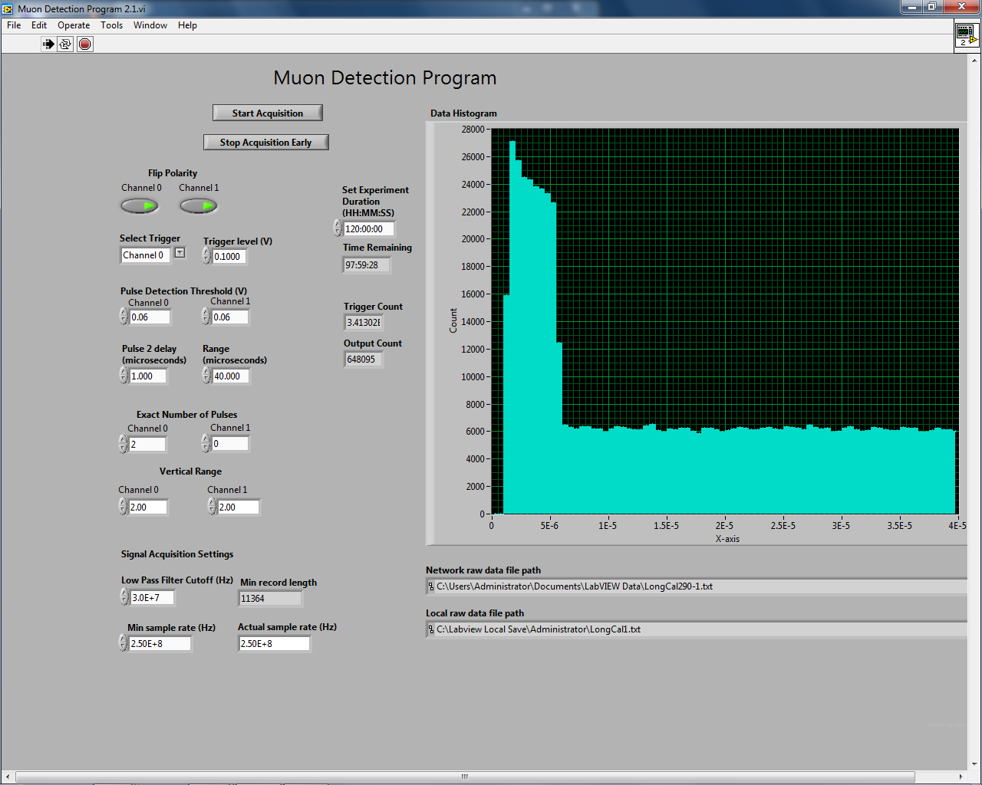

The above image is a screenshot taken at the conclusion of this 22-hour calibration run Cal100mV60mV30nS100mV290.*. Initially I puzzled over the taller bins of counts registered during the first 5 microseconds or so. Look at the amplitudes of the pulses in the calibration data file. Recall that one pulse must exceed the trigger level (perhaps not exactly the nominal 100mV displayed on the software GUI) in order for the software to look at it.

Alternatively, the Cal30nS-20kHz*.* data set may be used for the same purpose of determining the efficiency of the digitizer with respect to time difference between the pulses. For this data set only generated signals were used, from two separate DG645 signal generators. Trigger pulses were set to 100Hz and a second lower-amplitude pulse from the other signal generator a couple feet away set to 20000Hz (but not delivering exactly 200 times the other's frequency). This inexactness, as evidenced by the smaller pulse drifting across the 100Hz pulse on the scope every several seconds, was used to set up the calibration condition of an even distribution of pulse pairs across all pulse time differences. The height of the 100 Hz pulse was selected to be high enough to ensure triggering the PCI-5114, and the rate of 100Hz was selected to be slow enough that the digitizer's dead time analyzing a signal and plotting on the software's GUI would not interfere with collecting the next pulse. The height of the 20kHz pulse was selected to be too low to trigger the PCI-5114, thus ensuring it would only register as one of the two pulses when the trigger condition was already met by the larger pulse close before or after it in time. The 20kHz rate was selected to not permit two of these pulses to appear within the same waveform sample.

For all the above calibrations, the software was operated with Trigger at 0.1 Volts and Thresholds at 0.06 Volts.